JS Apps Exam – CarTube Single Page Application

Using libraries like jQuery, Handlebars and Sammy is allowed but is not obligatory. You are assigned to implement a Web application (SPA) using HTML5, JavaScript, AJAX, REST and JSON with cloud-based backend (Kinvey). The app keeps users and listings. Users can register, login, logout , view a catalog with all cars sorted by time (a helper function will be given), create a car listing, edit/delete their own listings,show listing details and a section where they can view their own listings.

Create a Kinvey REST Service

Register at Kinvey.com and create an application to keep your data in the cloud.
In the Users collection, import the provided JSON file with sample users to get started with template data. In the Kinvey Console, select Users from the navigation of the left, click Settings in the upper right then scroll down to the Import section:

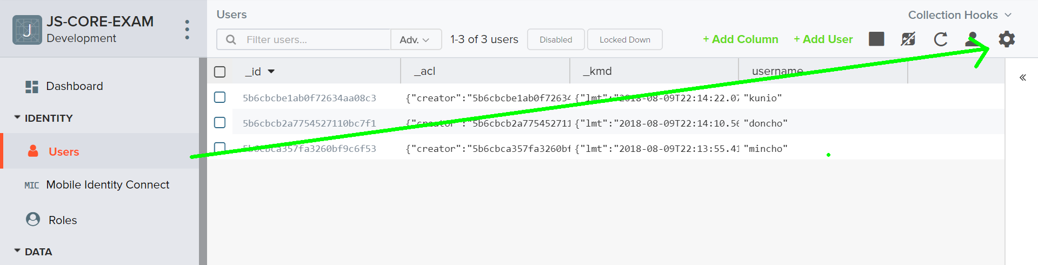

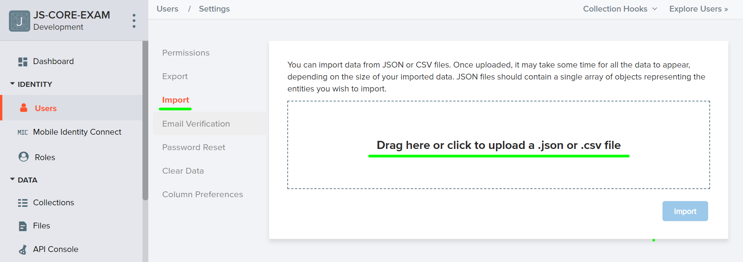

Create a collection cars. Each car has a title ,description ,imageUrl ,brand ,model ,fuel ,year ,price ,description and an seller (username of the seller).
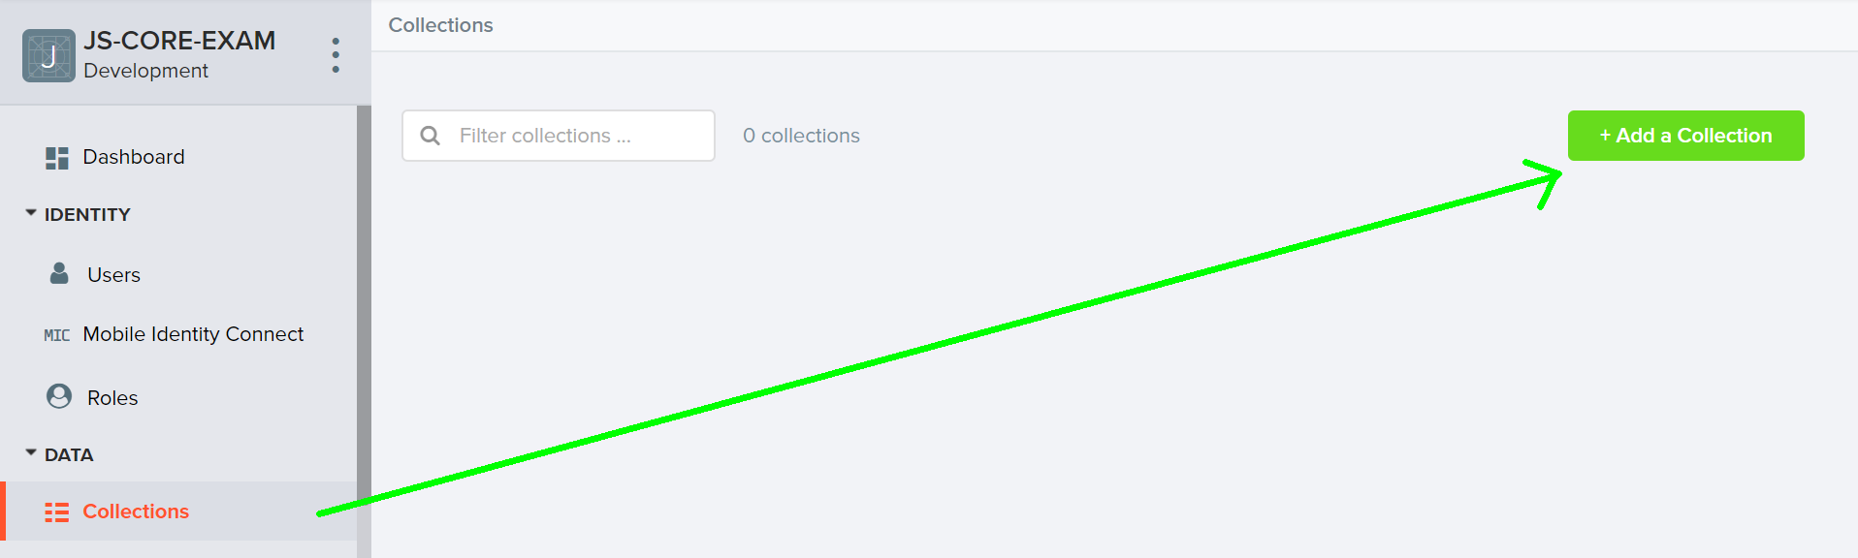
You are also given one more json files to import data for cars.

Test the Kinvey REST Services
Using Postman or other HTTP client tool (you can use Kinvey’s built-in API Console), test the REST service endpoints:

User Registration (Sign Up)
POST https://baas.kinvey.com/user/app_id/
Request headers | Authorization: Basic base64(app_id:app_secret)  Content-Type: application/json
Request body | {  "username": "testuser",  "password": "testuserpass890"  }
Response  201 Created | {  "_id": "59930c78a743e20c7d3fca77",  "username": "testuser",  "password": "testuserpass890"  }
Error response  409 Conflict | { "error": "UserAlreadyExists", "description": "This username is already taken. Please retry your request with a different username", "debug": "" }
Error response  401 Unauthorized | { "error": "InvalidCredentials", "description": "Invalid credentials. Please retry your request with correct credentials", "debug": "" }
The request needs “Basic” authentication. Use the Kinvey App Key and Kinvey App Secret as credentials.
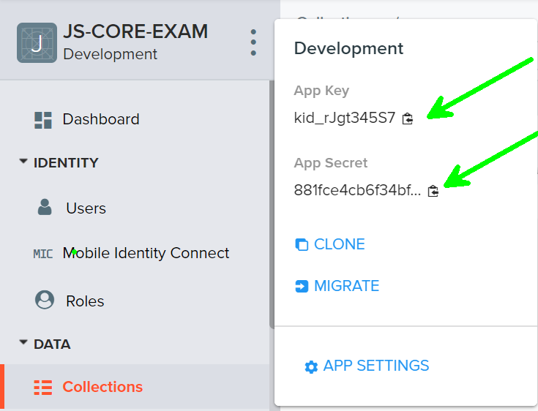

User Login
POST https://baas.kinvey.com/user/app_id/login
Request headers | Authorization: Basic base64(app_id:app_secret)  Content-Type: application/json
Request body | {  "username": "testuser",  "password": "testuserpass890"  }
Response  200 OK | {  "_id": "59930c78a743e20c7d3fca77",  "username": "testuser"  "_kmd": {  "authtoken": "8e6471bc-3712-4cfb-b92e-50e62a0c80….Duj5fHdM /7XHIe6KdY="  …  },  …  }
Error response  401 Unauthorized | { "error": "InvalidCredentials", "description": "Invalid credentials. Please retry your request with correct credentials", "debug": "" }
Successful login returns an “authtoken” which is later used to authenticate the CRUD operations.

User Logout
POST https://baas.kinvey.com/user/app_id/_logout
Request headers | Authorization: Kinvey authtoken
Response
204 No Content
Error response  401 Unauthorized | { "error": "InvalidCredentials", "description": "Invalid credentials. Please retry your request with correct credentials", "debug": "" }
To logout, you need to provide the “authtoken” given by login / register as “Kinvey” authorization header.

List all Cars (Catalog – sorted by car Listing time, descending)
GET https://baas.kinvey.com/appdata/app_id/cars?query={}&sort={"_kmd.ect": -1}
Request headers | Authorization: Kinvey authtoken
Response  200 OK | [  {  "brand": "BMW",  "description":"Нов внос, изобщо не е бълскана никога! Качваш се и караш!!!",  "fuel":"Gasoline",  "imageUrl":"url-link",  "isAuthor": true,  "model": "E92",  "price": "14000",  "seller": "mincho",  "title": "3er Coupe (E92) Нов внос!",  "year": "2007",  "_acl": {  "creator": "kid_B1zfi_e_Z"  },  "_kmd": {  "lmt": "2017-08-15T14:40:19.182Z",  "ect": "2017-08-15T14:40:19.182Z"  }  },...  ]
Error response  401 Unauthorized | { "error": "InvalidCredentials", "description": "Invalid credentials. Please retry your request with correct credentials", "debug": "" }

Create Car Listing
POST https://baas.kinvey.com/appdata/app_id/cars
Request headers | Authorization: Kinvey authtoken  Content-Type: application/json
Request body | {  "brand": "BMW",  "description":"Нов внос, изобщо не е бълскана никога! Качваш се и караш!!!",  "fuel":"Gasoline",  "imageUrl":"url-link",  "isAuthor": true,  "model": "E92",  "price": "14000",  "seller": "mincho",  "title": "3er Coupe (E92) Нов внос!",  "year": "2007",  }
Response  201 Created | {  "_id": "59931398996ab5127d2a84d1",  "brand": "BMW",  "description":"Нов внос, изобщо не е бълскана никога! Качваш се и караш!!!",  "fuel":"Gasoline",  "imageUrl":"url-link",  "isAuthor": true,  "model": "E92",  "price": "14000",  "seller": "mincho",  "title": "3er Coupe (E92) Нов внос!",  "year": "2007",  }
Error response  401 Unauthorized | { "error": "InvalidCredentials", "description": "Invalid credentials. Please retry your request with correct credentials", "debug": "" }

Edit Car Listing
PUT https://baas.kinvey.com/appdata/app_id/cars/car_id
Request headers | Authorization: Kinvey authtoken  Content-Type: application/json
Request body | {  "brand": "BMW",  "description":"Нов внос, изобщо не е бълскана никога! Качваш се и караш!!!",  "fuel":"Gasoline",  "imageUrl":"url-link",  "isAuthor": true,  "model": "E92",  "price": "14000",  "seller": "mincho",  "title": "3er Coupe (E92) Нов внос!",  "year": "2007",  }
Response  200 Ok | {  "_id": "59931398996ab5127d2a84d1",  "brand": "BMW",  "description":"Нов внос, изобщо не е бълскана никога! Качваш се и караш!!!",  "fuel":"Gasoline",  "imageUrl":"url-link",  "isAuthor": true,  "model": "E92",  "price": "14000",  "seller": "mincho",  "title": "3er Coupe (E92) Нов внос!",  "year": "2007",  }
Error response  401 Unauthorized | { "error": "InvalidCredentials", "description": "Invalid credentials. Please retry your request with correct credentials", "debug": "" }

Delete Car Listing
DELETE https://baas.kinvey.com/appdata/app_id/cars/car_id
Request headers | Authorization: Kinvey authtoken
Response  200 OK | {  "count": 1  }
Error response  404 Not Found | { "error": "EntityNotFound", "description": "This entity not found in the collection", "debug": "" }
Error response  401 Unauthorized | { "error": "InvalidCredentials", "description": "Invalid credentials. Please retry your request with correct credentials", "debug": "" }

My Car Listings (View all Car Listings by logged in user, sorted by post time, descending)
GET https://baas.kinvey.com/appdata/app_id/cars?query={"seller":"username"}&sort={"_kmd.ect": -1}
Request headers | Authorization: Kinvey authtoken
Response  200 OK | [  {  "_id": "599307d36af42b495f87bad2",  "brand": "BMW",  "description":"Нов внос, изобщо не е бълскана никога! Качваш се и караш!!!",  "fuel":"Gasoline",  "imageUrl":"url-link",  "isAuthor": true,  "model": "E92",  "price": "14000",  "seller": "mincho",  "title": "3er Coupe (E92) Нов внос!",  "year": "2007",  "_acl": {  "creator": "kid_B1zfi_e_Z"  },  "_kmd": {  "lmt": "2017-08-15T14:40:19.182Z",  "ect": "2017-08-15T14:40:19.182Z"  }  },  {  "_id": "5993178dbce993cf532bbe29",  "brand": "BMW",  "description":"Нов внос, изобщо не е бълскана никога! Качваш се и караш!!!",  "fuel":"Gasoline",  "imageUrl":"url-link",  "isAuthor": true,  "model": "E92",  "price": "14000",  "seller": "mincho",  "title": "3er Coupe (E92) Нов внос!",  "year": "2007",  "_acl": {  "creator": "59930c78a743e20c7d3fca77"  },  "_kmd": {  "lmt": "2017-08-15T15:47:25.376Z",  "ect": "2017-08-15T15:47:25.376Z"  }  }  ]
Error response  401 Unauthorized | { "error": "InvalidCredentials", "description": "Invalid credentials. Please retry your request with correct credentials", "debug": "" }

CarTube – HTML and CSS
You аre given the Web design of the application as HTML + CSS files.
- Initially all views and forms are shown by the HTML. Your application may hide by CSS (display: none) or delete from the DOM all unneeded elements or just display the views it needs to display.
- You may render the views / forms / components with jQuery or Handlebars.
Important: don’t change the elements’ class name and id. Don’t rename form fields / link names / ids. You are allowed to add data attributes to any elements. You may modify href attributes of links and add action/method attributes to forms, to allow the use of a routing library.

CarTube Client-Side Web Application
Design and implement a client-side front-end app (SPA) for managing car Listings. Implement the functionality described below.

Notifications
The application should notify the users about the result of their actions.
- In case of successful action an informational (green) notification message should be shown, which disappears automatically after 3 seconds or manually when the user clicks it.
- In case of error, an error notification message (red) should be shown which disappears on user click.
- During the AJAX calls a loading notification message (blue) should be shown. It should disappear automatically as soon as the AJAX call is completed.

NavBar (5 pts)
Implement a NavBar for the app: navigation links should correctly change the current screen (view).
- Clicking on the links in the NavBar or the links on each individual listing should display the view behind the link (views are sections in the HTML code).
- Your application may hide by CSS (display: none) or delete from the DOM all unneeded elements or just display the views it needs to display.
- The given „All Listings, My Listings, Create Listings, Welcome and logout“ should be visible only for logged in users. Anonymous users can only view the home and the regular navbar section.

Home Screen (10 pts)
The initial screen should display the navigation, register, login and the initial image + footer.

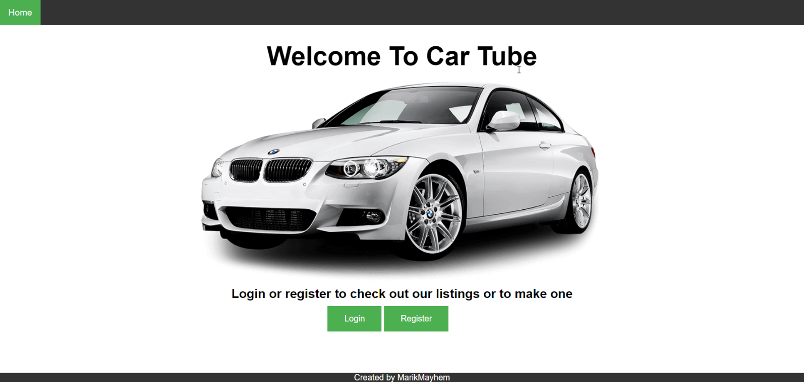

Register User (10 pts)
By given username, password and repeat password the app should register a new user in the system.
- After a successful registration, a notification message “User registration successful.” should be displayed and the catalog with all listings should be shown.
- You need to validate the input. A username should be at least 3 characters long and should contain only english alphabet letters. A user‘s password should be at least 6 characters long and should contain only english alphabet letters and digits. Both passwords must match.
- In case of error (eg. invalid username/password), an appropriate error message should be displayed and the user should be able to try to register again.
- Keep the user session data in the browser’s session storage.
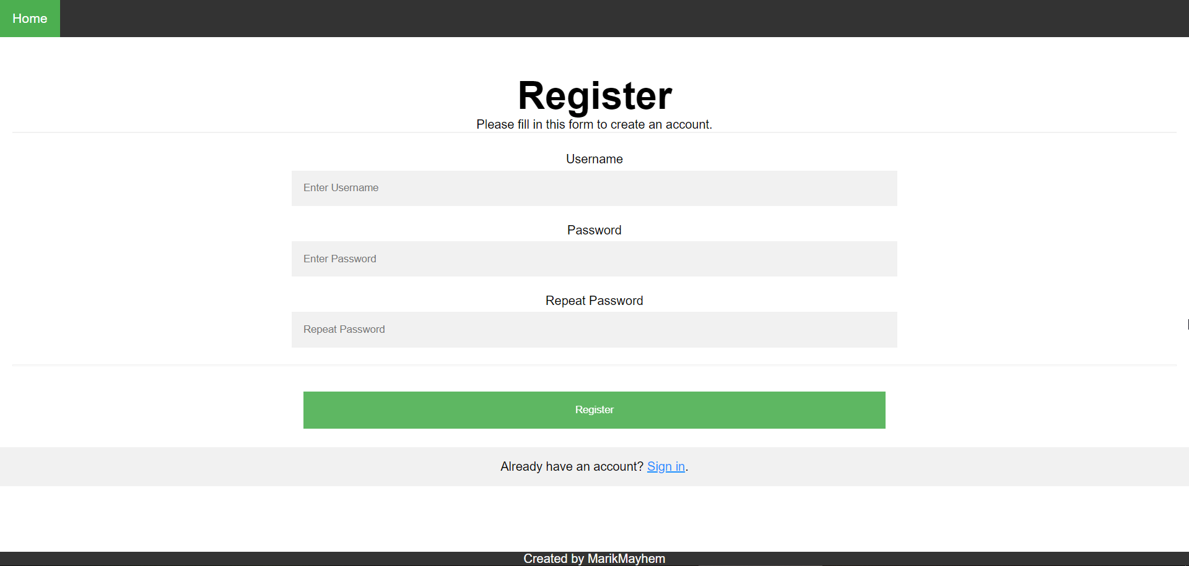

Login User (5 pts)
By given username and password the app should be able to login an existing user.
- After a successful login, a notification message “Login successful.” should be displayed and the user home screen should be displayed.
- In case of error, an appropriate error message should be displayed and the user should be able to fill the login form again.
- Form validation should be the same as register.
- Keep the user session data in the browser’s session storage.
- Clear all input fields after successful login.
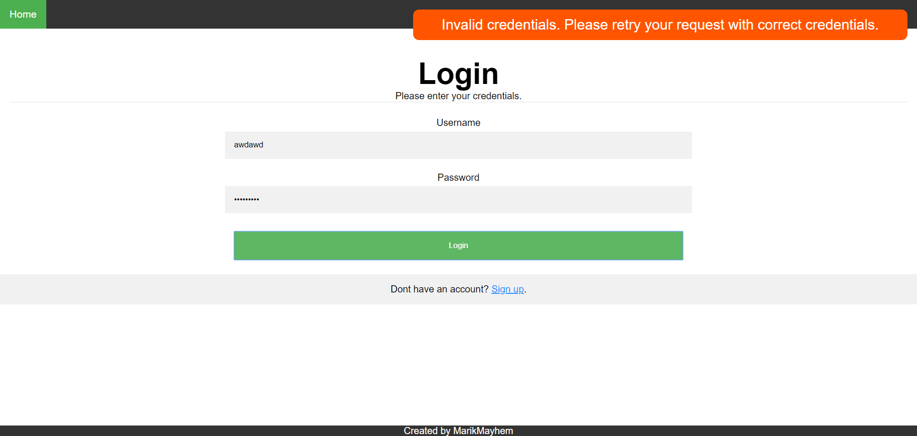

Logout (5 pts)
Successfully logged in user should be able to logout from the app.
- After a successful logout, a notification message “Logout successful.” should be displayed.
- After successful logout, the Sign In screen should be shown.
- The “logout” REST service at the back-end should be obligatory called at logout.
- All local information in the browser (user session data) about the current user should be deleted.

Logged In Home Screen (15 pts)
Successfully logged users should be welcomed by the catalog home screen which can be accessed after clicking the All Listings link in the NavBar. The catalog contains all listings on the site.
- The listings should be listed in the format as shown in the Web design (see the screenshot below).
- Each post has title, image, brand, seller, fuel, year, price.
- When the details/edit link is clicked, your app should redirect to the details/edit section of the listing.
- Listing authors can edit/delete their own listings.
- In case of error (e.g. Internet connection lost), an error message should be displayed.
- In case of no listings, display ‘No listings in database’.

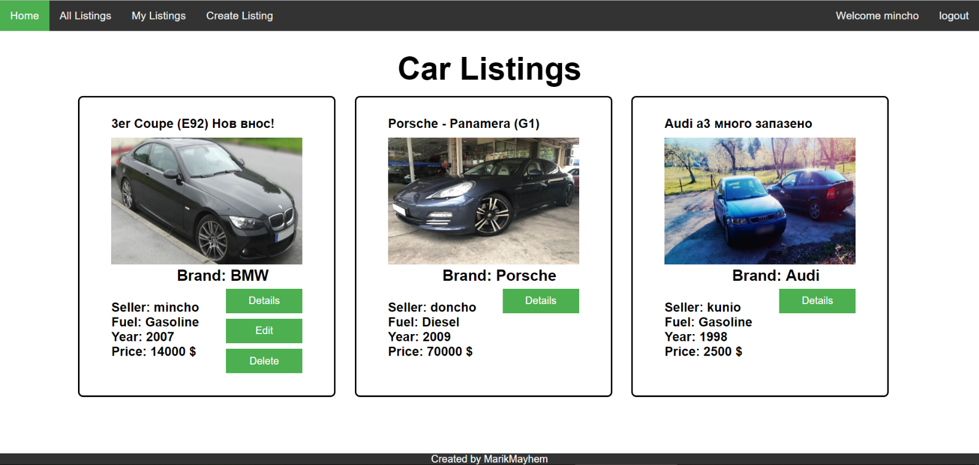

Create Listing Screen (10 pts)
Logged in users can create listings. Clicking the [Create Listing] link should open a form.
- After a successful listing creation, a notification message “listing created.” should be displayed and the home catalog should be shown.
- The title length must not exceed 33 characters!
- The description length must not exceed 450 characters and should be at least 30!
- The brand,fuelType and model length must not exceed 11 characters!
- The model length should be at least 4 characters!
- The year must be only 4 chars long!
- The maximum price is 1000000$
- Link url should always start with “http”.
- In case of empty/incorrect input fields an appropriate error message should be displayed and the user should be able to fill the form again.
- Ensure you handle properly all HTML special characters, e.g. the description text could hold "Hi, <peter>".
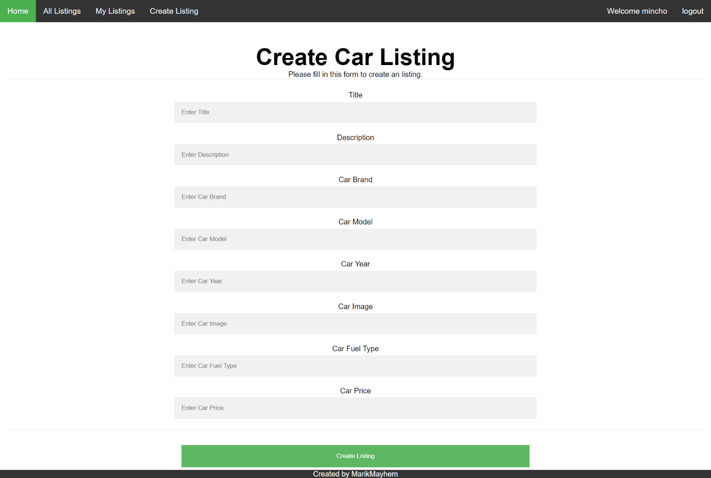

Edit Listing Screen (15 pts)
Sellers should be able to edit their own listings. Clicking the [Edit] link on each listing should open an edit form. Inside the edit form all input fields should be filled with the current data of each post.
- After a successful listing update, a notification message “Listing {listingTitle} updated.” should be displayed and the home catalog should be shown.
- The validation is same as create listing!
- Ensure you handle properly all HTML special characters, e.g. the description text could hold "Hi, <peter>".
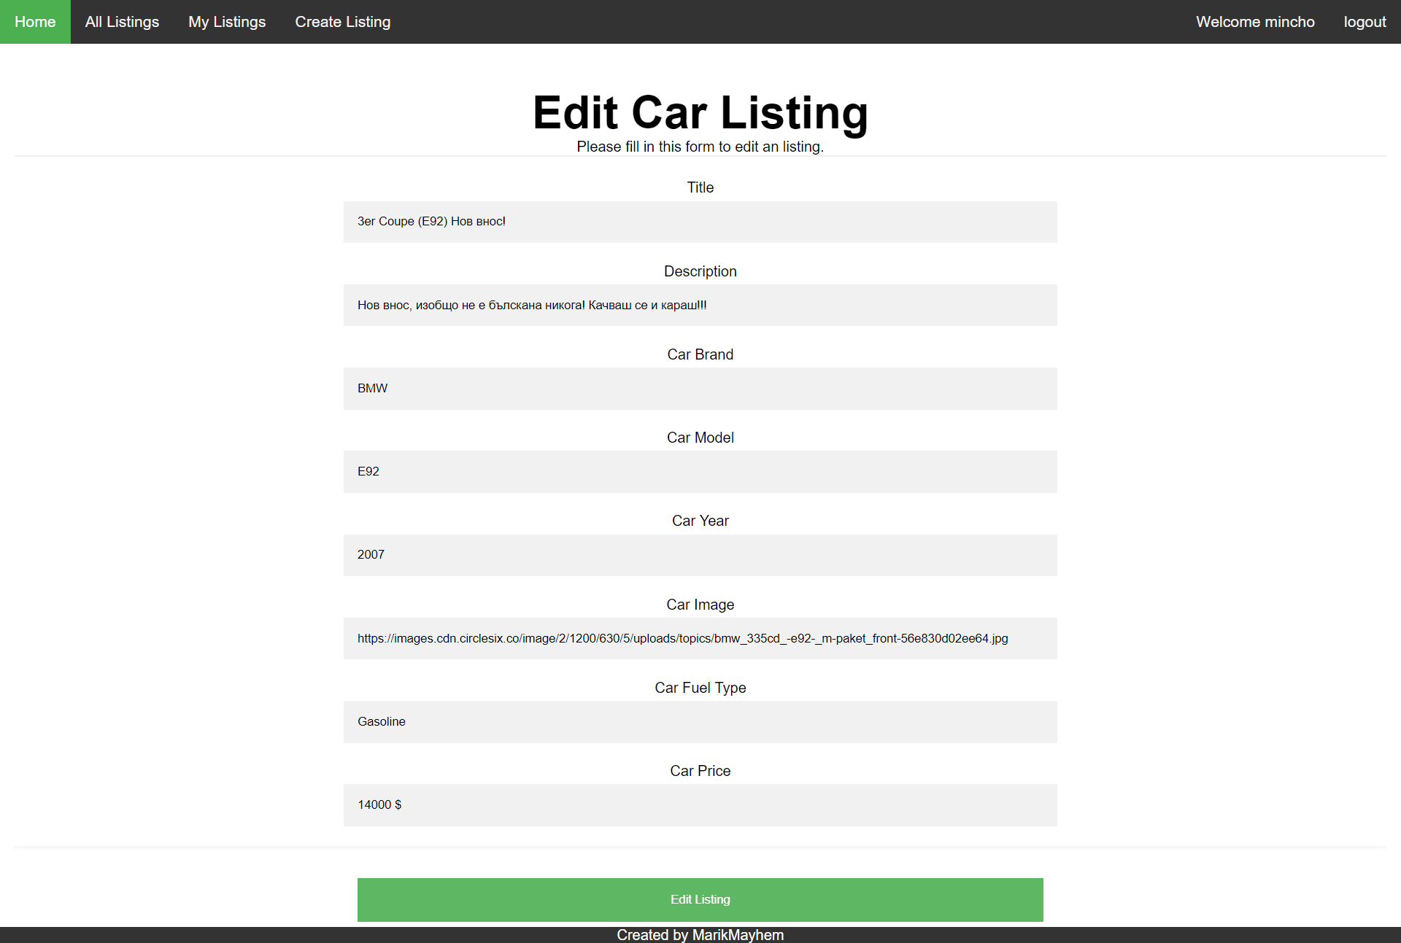

Delete Listing (5 pts)
Sellers should be able to delete their own listing by clicking the [Delete] button.
- After successful listing delete a notification message “Listing deleted.” should be displayed and the home catalog should be shown.
- In case of error (e.g. Internet connection lost / unauthorized request / missing message), an error message should be displayed.
- Deleting works immediately, with no confirmation.

My Listings (10 pts)
Each user should be able to view his own listings by clicking [My Listings].
- The listings should be listed like in the home catalog section.
- In case of error (e.g. Internet connection lost), an error message should be displayed.
- In case of no listings, display ‘No listings in database’.
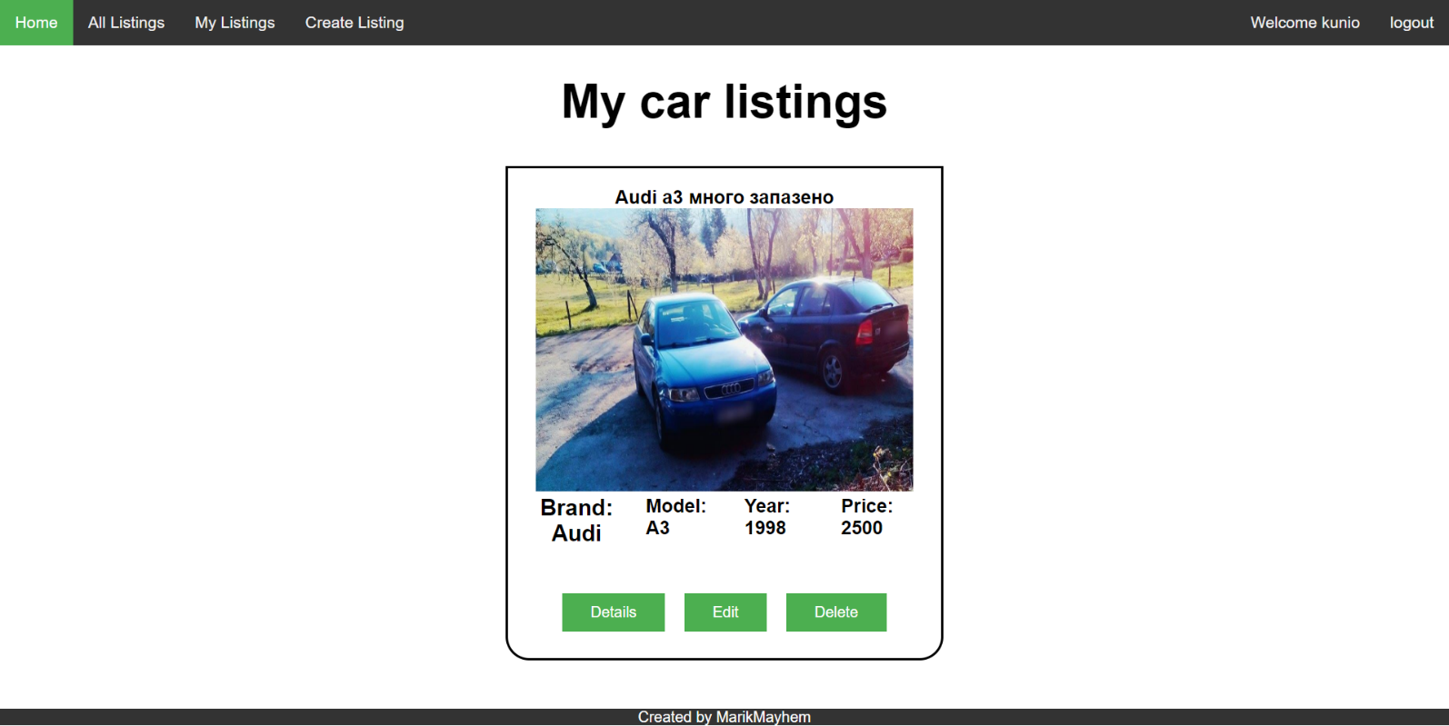

Listing Details (10 pts)
Each listing has a details view. By clicking the [details] link partial information about each post should be listed!
- In case of error (e.g. Internet connection lost), an error message should be displayed.
- Ensure you handle properly all HTML special characters, e.g. the description text could hold "Hi, <peter>".
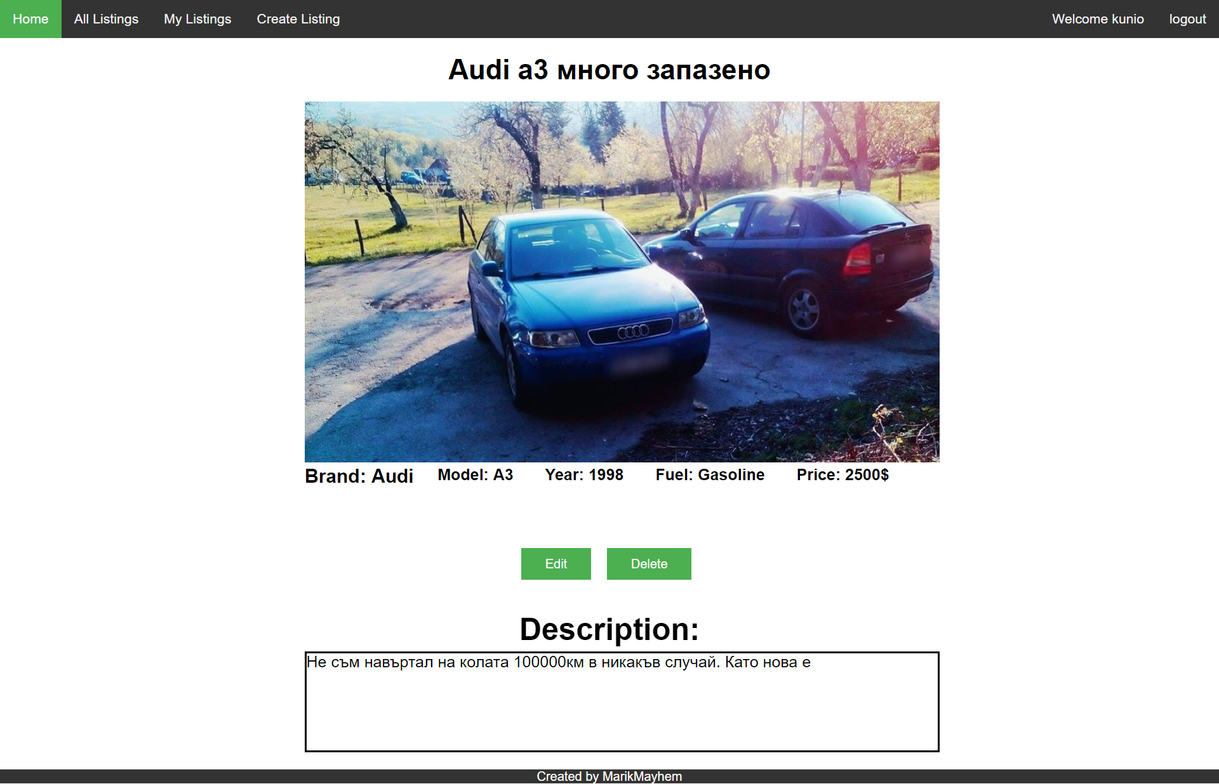

Subtmitting Your Solution
Place in a ZIP file your project folder. Exclude the node_modules folder. Upload the archive to the Judge.

